

*INTEGRATION WITH TRANSPORT*

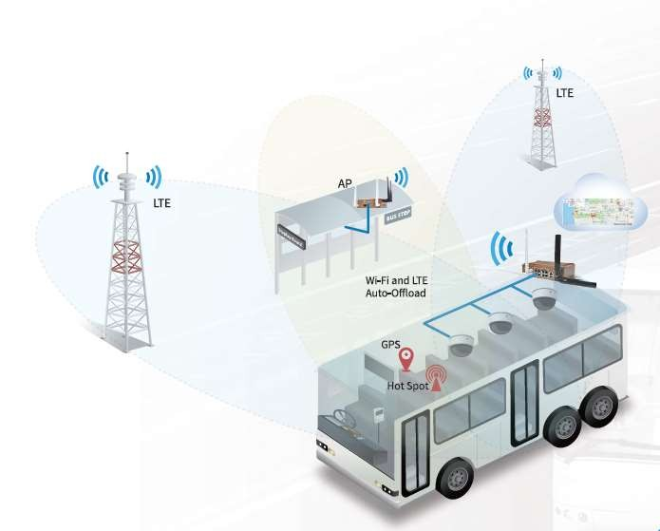**TEAM MEMBERS:**

* *SANJAYKUMAR. S*
* *MANIVEL. S*
* *NANDHAKUMAR. M*
* *NISHANTH. U*
* *SHRIHARIHARAN. C*

**MENTOR*:*** *PROFF. PRABHU*



# INTEGRATION WITH TRANSPORT:

* + DEFINITION:
* *1. Real-Time Transit Information: Integrate real-time updates on bus and train schedules into popular mapping apps like Google Maps or Apple Maps. This allows users to easily access accurate information on arrival times and plan their journeys accordingly.*
* *2. Intermodal Connectivity: Improve integration between different modes of transport, such as buses, trains, and bike-sharing services. This includes optimizing transfer points, providing clear signage, and ensuring seamless connections to enhance the overall travel experience.*



# EXISTING SYSTEM:

* + *The existing system of bus transport typically involves a network of routes and schedules to provide transportation services to passengers. Buses follow designated routes, pick up and drop off passengers at designated stops, and operate on a fixed schedule.*
  + *Passengers pay fares, either with cash or through electronic payment methods, to board the bus.*
  + *Bus transport plays a crucial role in providing affordable and accessible transportation options for people in urban and rural areas. 🚌*



* + - *LIABILITIES:*
    - *Traffic congestion becomes worse due to bad roads and constructions. Due to traffic congestions sudden changes of the bus routes were unknown.*
    - *As public transport vehicles don’t stop at specific destinations, you must take care of your travel from the stand or station to reach your desired stop. Privacy is a big issue in public transport. There are a lot of crowds, and sometimes you need more space to sit.*
    - *The timings of the public transport timetable may differ from your timings. It leads to increased waiting time and disturbance of your routine. The limited space may be uncomfortable for women with children or disabled people as personal vehicles.*



# SENSOR DESIGN:

Rador sensor

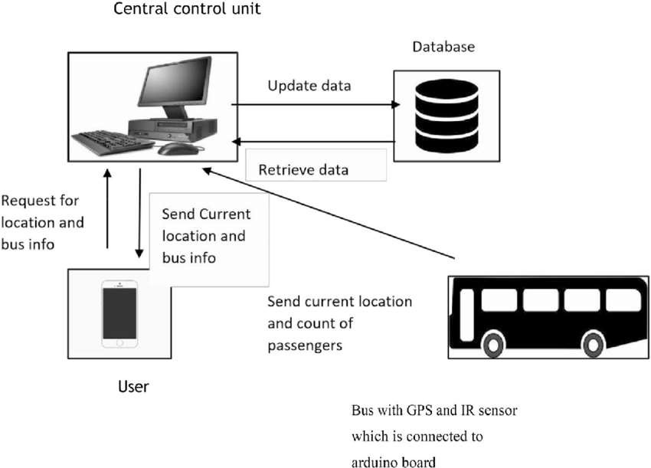

# WORKINGS:



* GPS SENSOR

1. GPS Tracking: GPS sensors installed in buses receive signals from multiple satellites to determine the precise location of the bus. This information is then transmitted to a central server or cloud platform through the internet.
2. 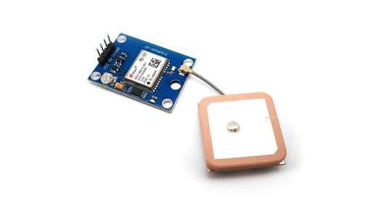Real-Time Monitoring: The data from GPS sensors allows transportation authorities or operators to monitor the position of buses in real-time. This enables them to track the progress of each bus, ensure adherence to schedules, and provide accurate arrival time information to passengers.
3. Route Optimization: By analyzing the GPS data, transportation authorities can identify traffic patterns, congestion points, and areas with high demand. This information can be used to optimize bus routes, improve efficiency, and reduce travel times.

# Functionality and technology of radar sensors | Baumer internationalWORKINGS:



* RADOR SENSOR

1. Collision Avoidance: Radar sensors can detect objects in the bus's vicinity and provide warnings to the driver if there is a risk of collision. This helps improve safety by alerting the driver to potential hazards, such as pedestrians or vehicles in blind spots.
2. Adaptive Cruise Control: These sensors measure the distance to the vehicle ahead and adjust the bus's speed accordingly, maintaining a safe following distance.
3. Blind Spot Detection: Radar sensors can assist in detecting vehicles or objects in the bus's blind spots. This helps the driver make safer lane change decisions and reduces the risk of accidents.



# Sensor implementation:

* + Step 1: Choose the GPS and RADAR sensor compatible with bus control system. Install the GPS sensor typically on the roof top for better signal reception. Place the RADAR sensor in rear bumper to provide comprehensive view of surrounding.
  + Step 2: The GPS and RADAR data can be integrated into a central control unit where

the information from both sensors is processed by a multicore processor.

* + Step 3: Use GNSS\SDR software to process the GPS and MATPLOTLIB to process

RADAR data to detect obstacles and provide collision and tracking signal to users.

* + Step 4:To store historical GPS and RADAR data for analysing routes, fuel efficiency

and maintaining schedules we use memory elements.

* + Step 5: Create a website or web application to display the processed radar data by using HTML, CSS, JavaScript for framework to streamline development. To plot the GPS integrating the data with website by implementing the Google maps API, Mapbox and create custom visualization of the data from control unit.



# APPLICATIONS:

1. 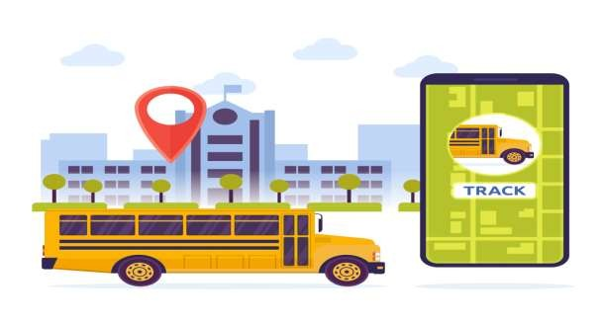Navigation: GPS helps drivers and passengers find the best

routes, saving time and reducing congestion.

1. Fleet Management: GPS enables real-time tracking of vehicles, allowing companies to monitor their fleet, optimize routes, and improve efficiency.
2. Collision Avoidance: Radar sensors can detect objects in the bus's vicinity and provide warnings to the driver if there is a risk of collision.
3. Adaptive Cruise Control: These sensors measure the distance to the vehicle ahead and adjust the bus's speed accordingly, maintaining a safe following distance.



* + *Benefits of proposed system:*

## GPS (Global Positioning System) provides accurate location information, helping drivers navigate and find the best routes to their destinations. It also enables features like real-time traffic updates and turn-by-turn directions, enhancing convenience and efficiency.

1. Radar sensors also play a role in adaptive cruise control systems, maintaining a safe distance from the vehicle ahead by adjusting the vehicle's speed. This enhances safety and reduces driver fatigue during long drives.

## In parking situations, radar sensors help drivers detect obstacles and provide assistance in maneuvering the vehicle safely into parking spaces. This makes parking easier and reduces the risk of collisions.



THANK YOU!